Quarterly Report – Public Page

Date of Report: 8th Quarterly Report, September 30, 2025
Contract Number: 693JK32310010POTA
Prepared for: Government Agency: DOT and Co-funders
Project Title: Standardize the Application of Vapor Corrosion Inhibitors
Prepared by: Pipeline Research Council International (PRCI), Inc.
Contact Information: Janie Norton, jnorton@prci.org 703-205-1600 ext: 105
For quarterly period ending: September 30, 2025

1: Items Completed During this Quarterly Period:

Item # | Task # | Activity/Deliverable | Title | Federal Cost | Cost Share
19 | 4 | Start developing the VCI application best practice guidance | Summary to be included in the quarterly report | $6,254 | $1,564
20 | 3 | Initiate VCI migration experiments | Summary of the VCI migration to be included in the quarterly report | $20,848 | $5,212
21 | 5 | 8th quarterly status report & project management | Submit 8th quarterly report | $7,449 | $1,861

2: Items Not Completed During this Quarterly Period:

None.

3: Project Financial Tracking During this Quarterly Period:

Note that this chart reflects Federal share only:
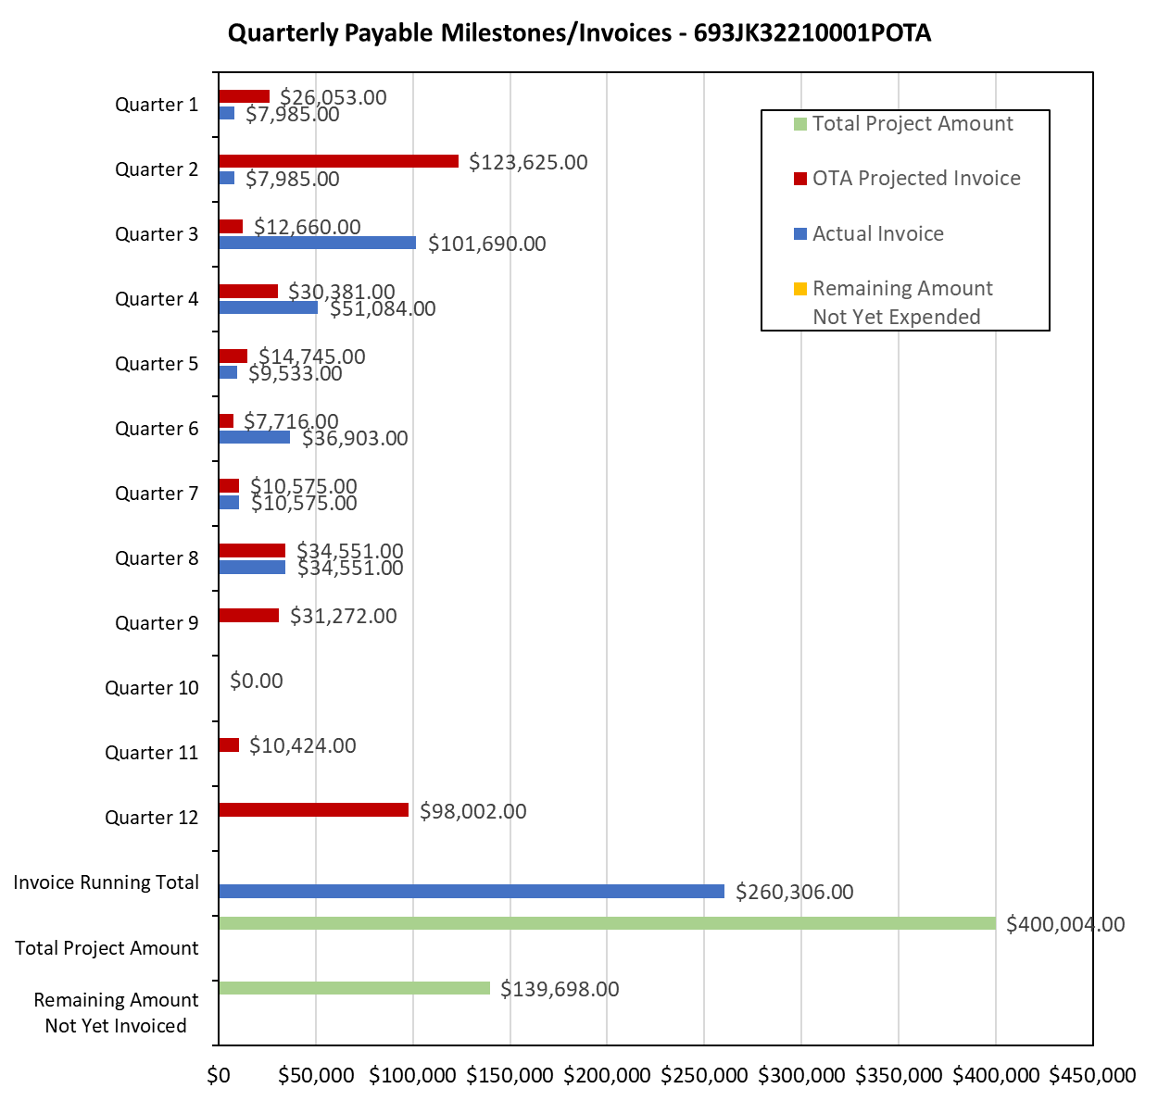

4: Project Technical Status –

Item 19, Task 4 ⎯ Start developing the VCI application best practice guidance. Summary to be included in the quarterly report: As a part of developing the guideline, a comparison is made between API TR 655 and AMPP SP 21474; both documents’ overall scope include application and monitoring of the VCIs for the aboveground storage tank bottoms. The comparison is listed in Table 1.

Table 1. Comparison Between API TR 655 and AMPP SP 21474
Scope | API TR 655 | AMPP SP 21474
VCI Application Method | Includes application description for both in-service and out of service tanks.  Both single and double bottom tanks. | Provides recommendations and methods for applying VCIs to both single and double bottom tanks.
VCI monitoring | The document recommends using coupons, ER probes, and UT probes. | The document recommends using mass-loss based technologies including coupons for monitoring.  Specific recommendations for placing and reading the monitoring tools.  The placement of the monitoring tools based on the API 653 floor inspection data is also recommended.
VCI reapplication criterion | No specific reapplication criterion is provided in the document. However, the document mentions using monitoring data as a basis to determine the replication timeframe. | The following criterion is mentioned: if a 5-mpy, or greater, corrosion rate is measured with a monitoring device over 2-consecutive measurement periods, the VCI shall be replenished. At a minimum, the VCI shall be replenished within the specific tank quadrant area where the corrosion monitoring device is located. In addition, if the tank bottom inspection results identify corrosion indications of 5-mpy, or greater, the VCI shall be replenished.
VCI reinjection/replenishment dosages | No information is provided. | No information is provided.
VCI and CP compatibility | The document mentions of the following:  - synergistic effect of VCI on CP, and  - VCIs effect on tank pad resistivity and overall effect on | Not mentioned in the documents.

This activity links to item 10 in Attachment 1 Team Project Activities. This activity links to item 12 in Attachment 2 Project Deliverables.

References:

- API, API Technical Report (TR) 655: Vapor Corrosion Inhibitors for Storage Tanks, Washington, DC: American Petroleum Institute (API), 2021.
- AMPP, AMPP SP21474: External Corrosion Control of On-Grade Carbon Steel Storage Tank Bottoms, Houston, Texas: AMPP International, Standard Practice (SP) 21474, 2023.
- API, API Standard 653: Tank Inspection, Repair, Alteration, and Reconstruction, Washington, DC: American Petroleum Institute (API), 2014.

Item 20, Task 3 ⎯ Initiate VCI migration experiments. Summary of the VCI migration experiments to be included in the quarterly report: The VCI migration experiments were setup at the end of July 2025. Two experiments were setup using ASTM C778 minus sieve 20 sand. Salts were added to the sand such that the chloride and sulfate concentrations were 30 and 15 ppm, respectively. The moisture content of the sand was 50%. Images of the experiments is shown in Figure 1.

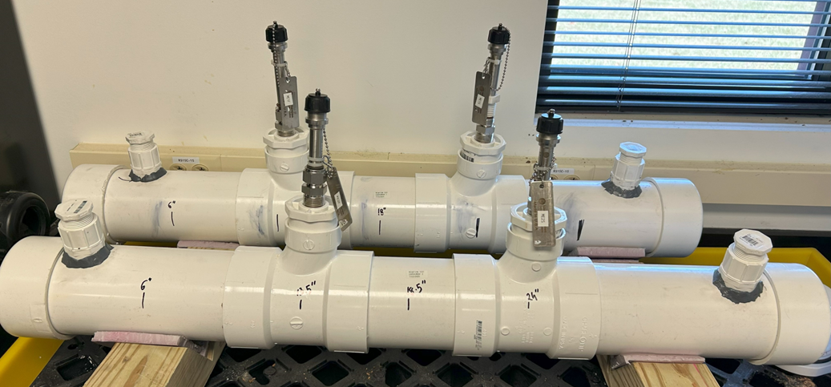
Figure 1. Images of the two side-by-side migration experiments.

Two electrical resistance (ER) probes and several coupons were placed each experiment. The ER probe data from the two probs in each experiment is presented in Figure 2.

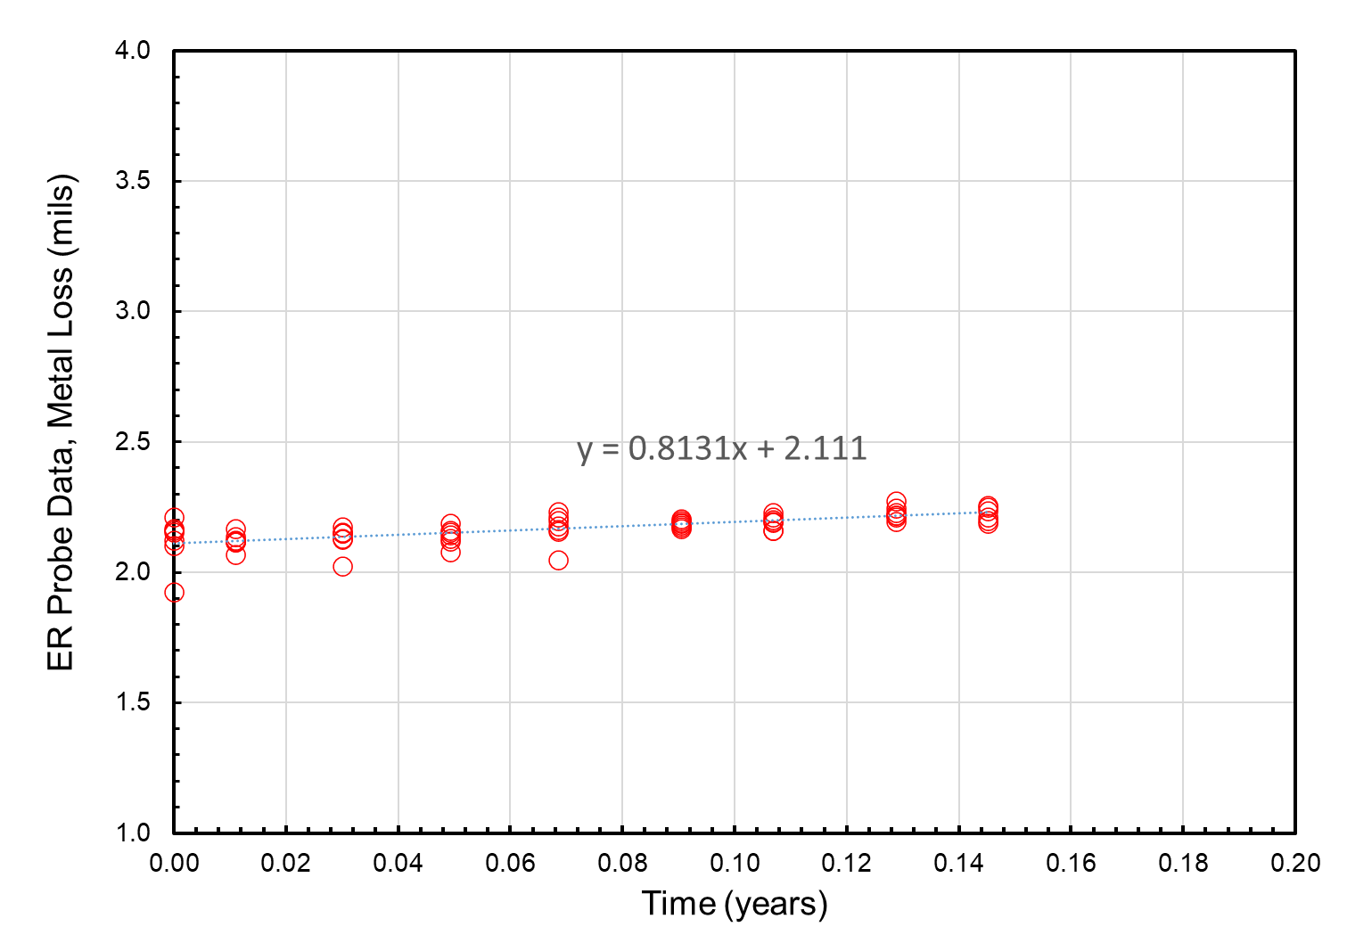 | 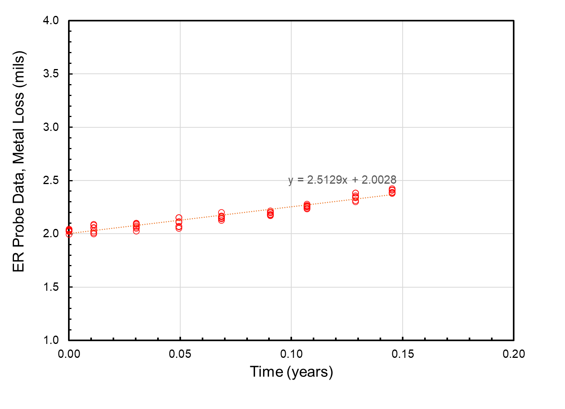
- Experiment 1 first ER probe | - Experiment 2 second ER probe
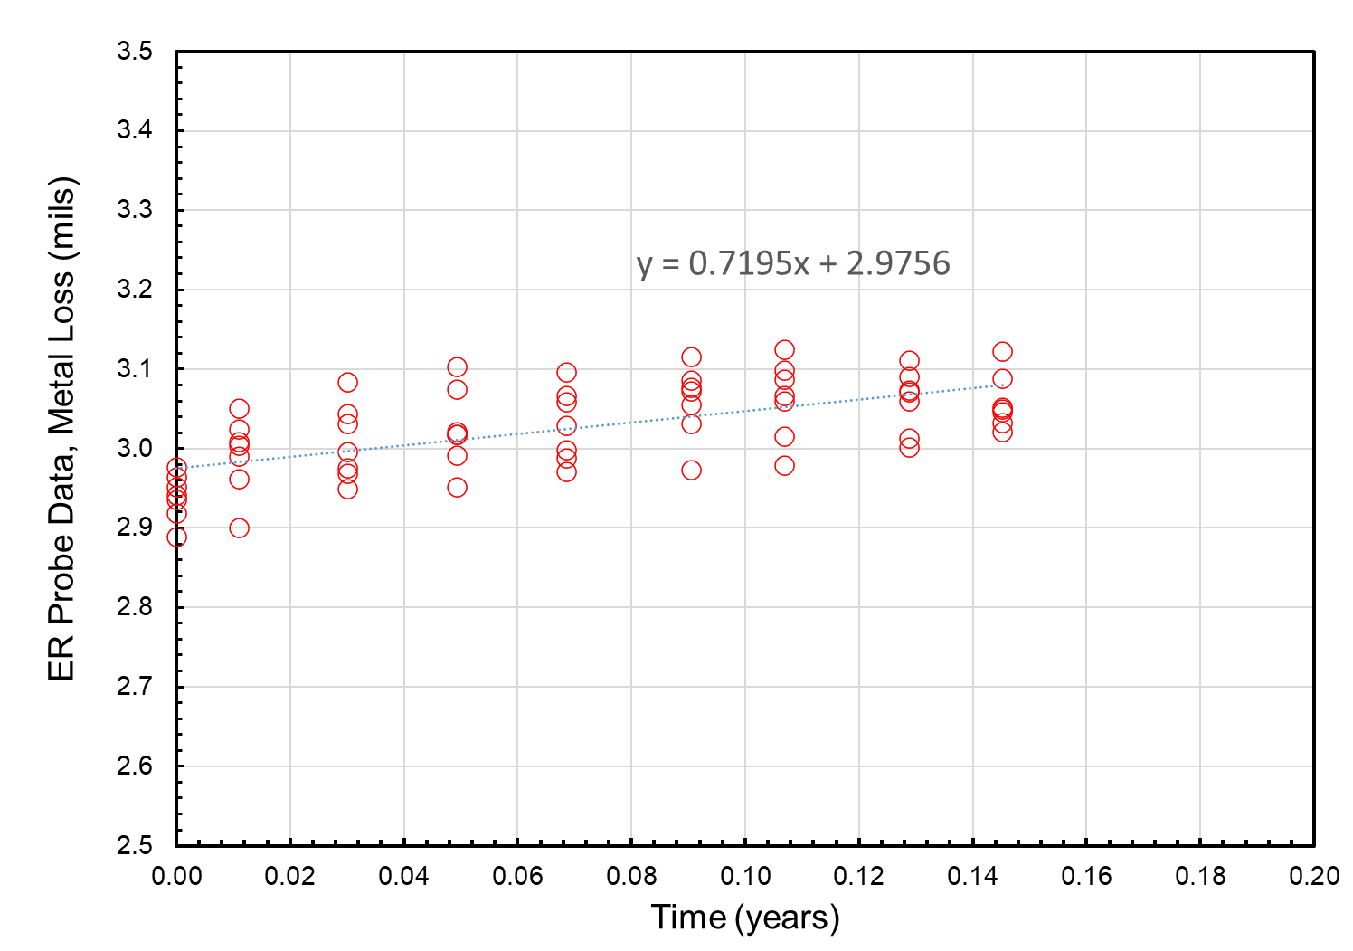 | 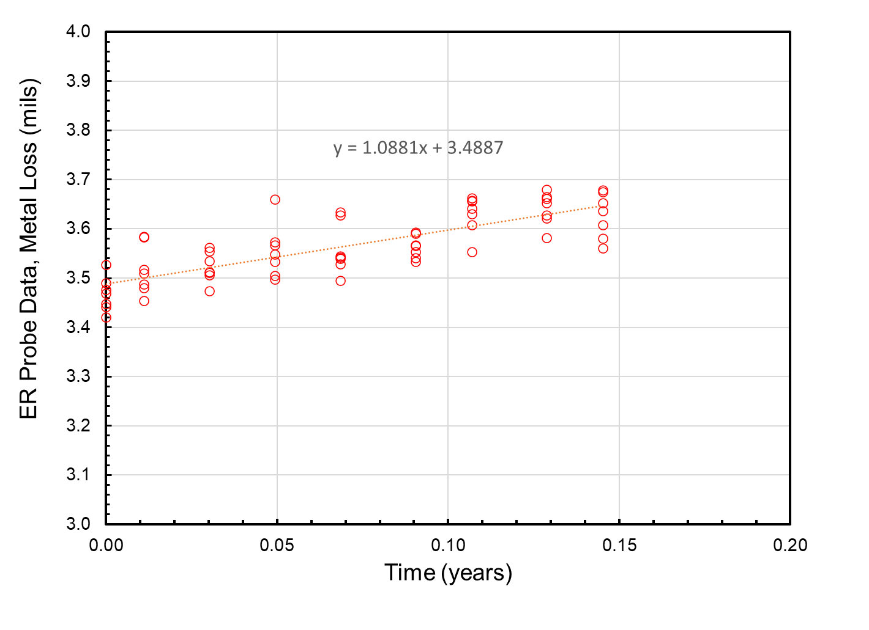
- Experiment 2 first ER probe | - Experiment 2 first ER probe
Figure 2. ER probe data from the two migration experiments.

This activity links to items 6 and 7 in Attachment 1 Team Project Activities. This activity links to item 9 in Attachment 2 Project Deliverables.

Reference:

- ASTM, ASTM C778-21: Standard Specification for Standard Sand, West Conshohocken, PA: ASTM International, 2021.

Item 21, Task 5 ⎯ 8th quarterly status report & project management. Submit 8th quarterly report: The eighth quarterly meeting was held on September 4, 2025. This report satisfies this item. This activity links to items 11 and 13 in Attachment 1 Team Project Activities. This activity links to item 13 in Attachment 2 Project Deliverables.

5: Project Schedule –

The project is on schedule.

